Comparison of Ward Hierarchical Clustering and the K-means clustering Analysis in R

1.Abstract
In statistical modeling, cluster analysis or clustering is a task to partition a set of objects, based on the characteristic of the objects. The objects in the same groups have more similar feature than the objects from other groups (1). Unlike regression analysis, clustering is an unsupervised approach in data mining, which means the outputs is not given in the test. Thus, the number of groups should be separated is not fixed.
Most clustering algorithms are derived from the two popular approaches: hierarchical clustering and iterative square-error partitional clustering. In this paper, I will show two algorithms based on above approaches, the ward hierarchical clustering and the k-means clustering. (2)
Before implement the clustering approach, preprocess data are required. Since all data are from a huge messy raw dataset. The raw dataset contains high dimensions, meanwhile, most attributes in the dataset are with missing value. Furthermore, some values in a certain column are estimated, not measured. Before building the regression model, we need preprocess data and make sure the new dataset be able to work in the model.
This paper shows the steps of preprocessing the raw dataset, checking best group number, implement the algorithms and validate the results.

Keywords: cluster analysis, preprocessing data, attribute, dataset.

Comparison of Ward Hierarchical Clustering and the K-means clustering Analysis in R
- Background about the data.
The dataset is from ‘International Comprehensive Ocean-Atmosphere Data Set (ICOADS)’(3). ICOADS is a global ocean marine meteorological and surface ocean dataset. It is consisted of combination of many national and international data sources that contain measurements and visual observations from moored and drifting buoys; merchant, navy, or research ship; coastal stations, and other marine platforms. Based on date and geographic position with regard to shipping routes and ocean observing systems, it covers various global and sampling density. The monthly summary time series are available at 2-degree (since 1800) and 1-degree (since 1960) spatial resolutions. Twenty-two statically summarized data which were observed and computed parameters have been taken every month from a give spatial latitude by longitude box. In this paper, the time span is from Sept 1 to Sept 30 in 1986. Total 48 attributes are selected to parsed into file ‘noaa_data_parsed.csv’.
- How to implement data.

2.1 Software tools.
R is a language and environment for statistical computing and graphics (4). In this paper, I use RStudio 1.1.414, a graphical user interface of R, to demonstrates my process of model and output.
2.2 How to preprocess the data.

2.2.1 First, delete low value rows and columns.

There are total 289,000 rows and 48 columns in the dataset, samples in five columns are less

than 100, thus, these five columns were deleted manually first. Then, I import the dataset to

R_studio, the option in left bottom ‘na.strings’ NA will automatically transform all blank value

to ‘NA’. You can see the output in Data Frame in PICTURE1.

PICUTRE1
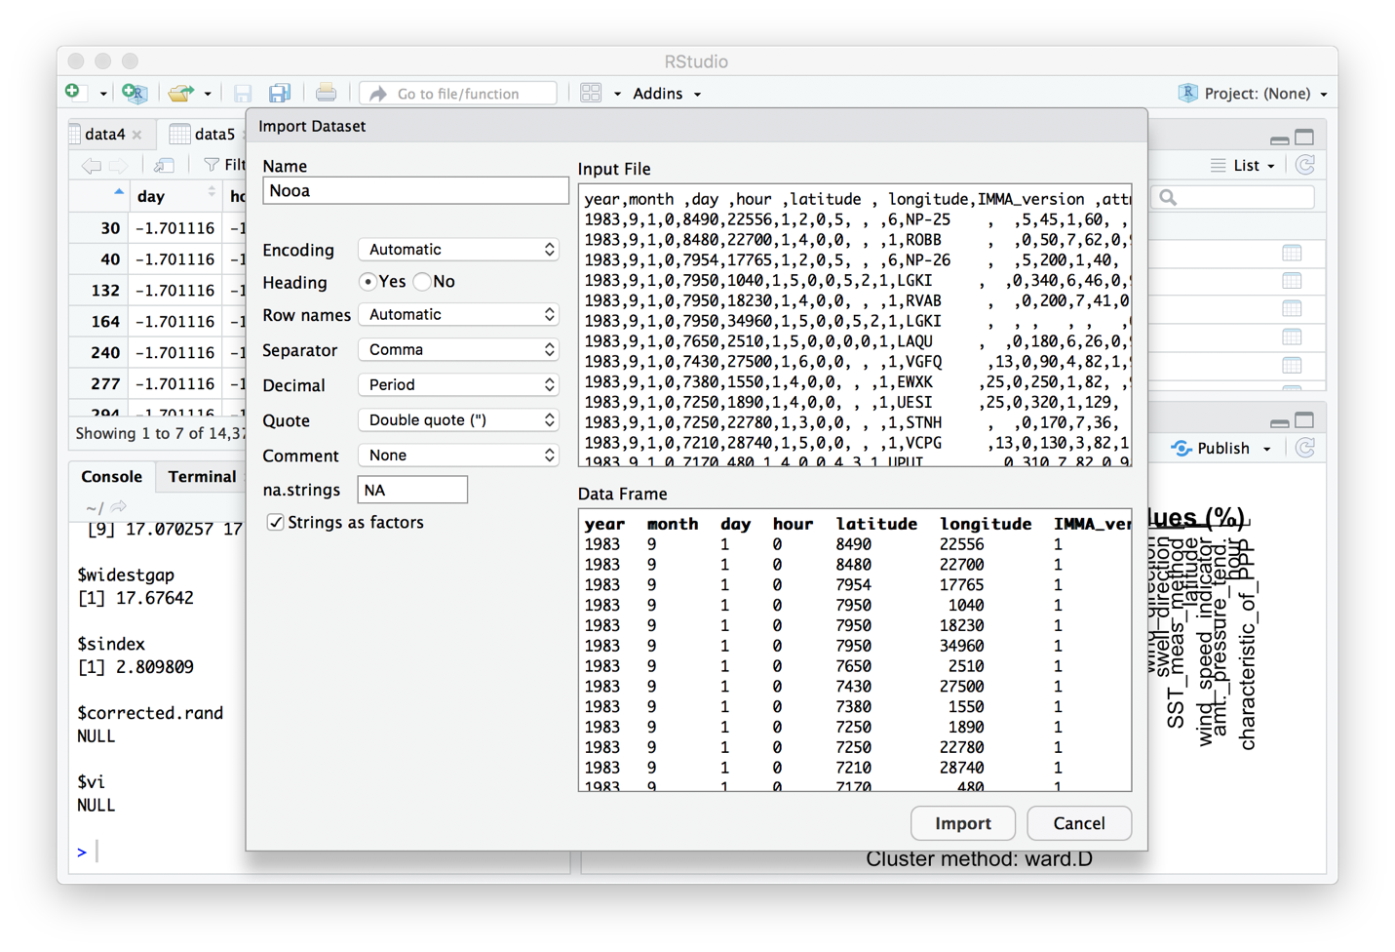

After dataset has been imported, we can check how many rows are with ‘NA’ as below:

> Nooa <- read.csv("~/Desktop/632/Project/project3/Nooa.csv")
> View(Nooa)
> data3=Nooa
> row.has.na <- apply(data3, 1, function(x){any(is.na(x))})
> sum(row.has.na)
[1] 275325

According to the result, there are 275,325 rows with ‘NA’.

> data4=na.omit(data3)
> View(data4). # data4 is the file with no missing data

After removing all rows with ‘NA’, a new dataset with 14,375rows and 43 attributes is

generated.

2.2.2 Second, convert categorical variables to numeric and standardize the dataset.

First convert categorical variables to numeric in the dataset.

> data4 <- data.frame(data4)
> data4[] <- lapply(data4, as.integer) # convert
> str(data4)
'data.frame': 14375 obs. of 44 variables:
$ year : int 1983 1983 1983 1983 1983 1983 1983 1983 1983 1983 ...
$ month : int 9 9 9 9 9 9 9 9 9 9 ...
$ day : int 1 1 1 1 1 1 1 1 1 1 ...

Since the dataset have mixed numerical data, where each attribute is something entirely different,

has different units attached, and these values aren't really comparable anyway; I need z-

standardizing them to give equal weight to them.

> data4=scale(data4)
> head(data4)
year month day hour latitude
30 NaN NaN -1.701116 -1.501933 1.5157637
40 NaN NaN -1.701116 -1.501933 1.4551682
132 NaN NaN -1.701116 -1.501933 1.1664483

Unfortunately, values in 5 columns turn to ‘NaN’ after scale function due to the max-min value

is zero. Thus, I deleted these five functions by below code:

> data5=data4[,!apply(is.na(data4), 2, any)]
> View(data5)
> head(data5)
day hour latitude longitude
30 -1.701116 -1.501933 1.5157637 -1.8126596
40 -1.701116 -1.501933 1.4551682 -1.8289910
132 -1.701116 -1.501933 1.1664483 -1.8837013

Now the preprocess part is over. Totally 39 attributes in the new dataset, which is a high

dimensional dataset.

2.3 Implementation of the two algorithms.

2.3.1 Implement K-means clustering.

K-means clustering is a typical algorithm based on iterative square-error partitional clustering,

which stores k centroids to define clusters. K is an input of the algorithm, a point is considered to

be in a particular cluster if it is closer to that cluster's centroid than any other centroid.

K-Means starts with a random, initial partition and keeps reassigning the samples to clusters,

based on the similarity between samples and clusters, until a convergence criterion is met. (5)

For this reason, the number of cluster need to be picked before implementation,

2.3.1.1 Detect the number of groups.

To determine the suitable number of clusters and plot the result.

wss <- (nrow(data4)-1)*sum(apply(data4,2,var))
for (i in 2:15) wss[i] <- sum(kmeans(mydata, centers=i)$withinss)
plot(1:15, wss, type="b", xlab="Number of Clusters", ylab="Within groups sum of squares")

GRAPH1
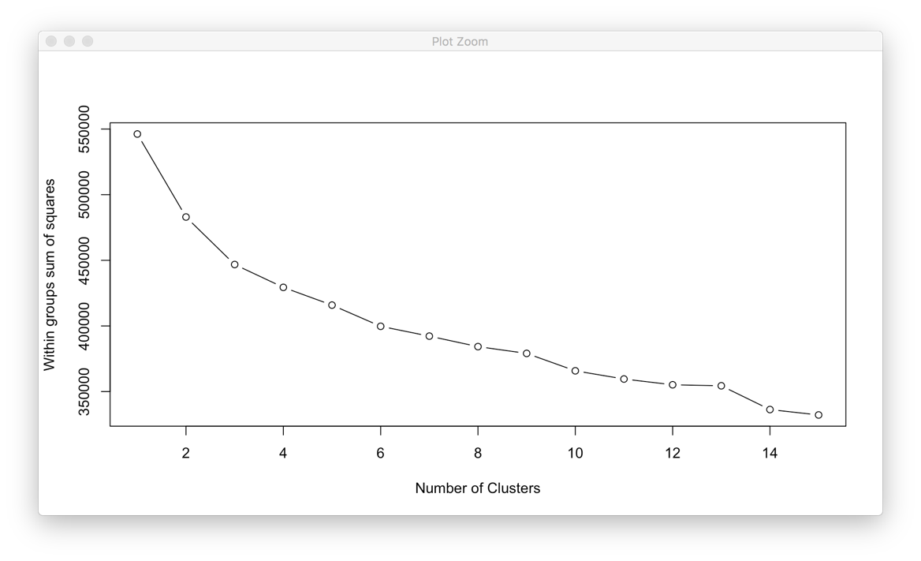
According to GRAPH1, when the number of clusters is 10, value of within groups sum of
squares is around 37,000, therefore 10 is an appropriate number for partition.
2.3.1.2 Implement K-means clustering with k equal to 10.
K-means clustering algorithm can be run in R as below:
> fit <- kmeans(data5, 10)
> aggregate(data5,by=list(fit$cluster),FUN=mean)
> data5 <- data.frame(data5, fit$cluster)
> library(cluster)
> clusplot(data5, fit$cluster, color=TRUE, shade=TRUE, labels=2, lines=0)

Since the attributed number is nearly 40, the high dimensional dataset can be only plot into 2D

graph as GRAPH2.

GRAPH2
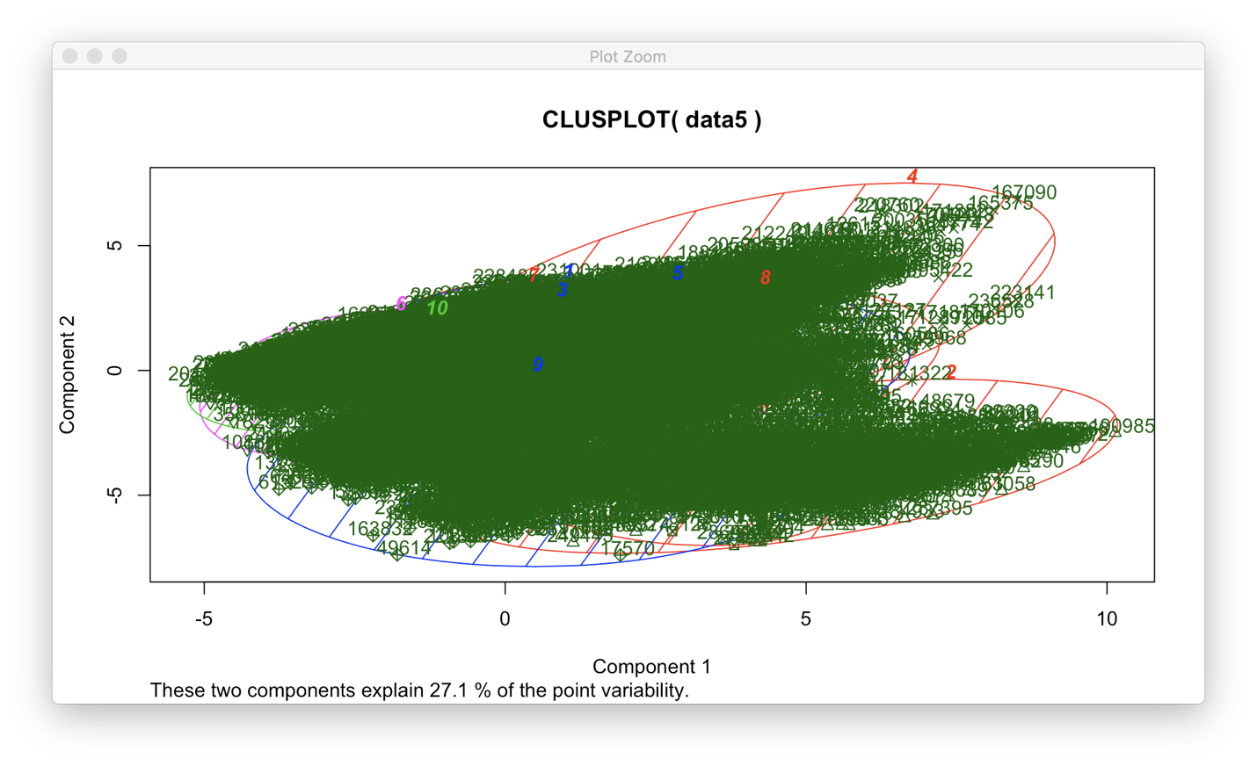
2.3.2 The ward hierarchical clustering.
The foundation of the ward hierarchical clustering is hierarchical clustering. It creates a hierarchy of clusters, and presents the hierarchy in a dendrogram. The number of clusters is not the input for this algorithm. First a distance similarity measure is generated to combine or split clusters. Then, the recursive process keeps on until there is only one cluster left or you cannot split more clusters. Eventually, we can use a dendrogram to represent the hierarchy of clusters.
We can use agglomerative hierarchical clustering to cluster the dataset: use the Euclidean distance as distance metrics, and use Ward's minimum variance method(6) to perform agglomerative clustering.
hc = hclust(dist(data5, method="euclidean"), method="ward.D2")
As far as we know when the number of groups is equals to 10, we got better result. We can plot
the dendrogram first then categorize the data into 10 groups:
plot(hc, hang = -0.01, cex = 0.7)
fit9 = cutree(hc, k = 10)
rect.hclust(hc, k=10, border="red")

GRAPH3
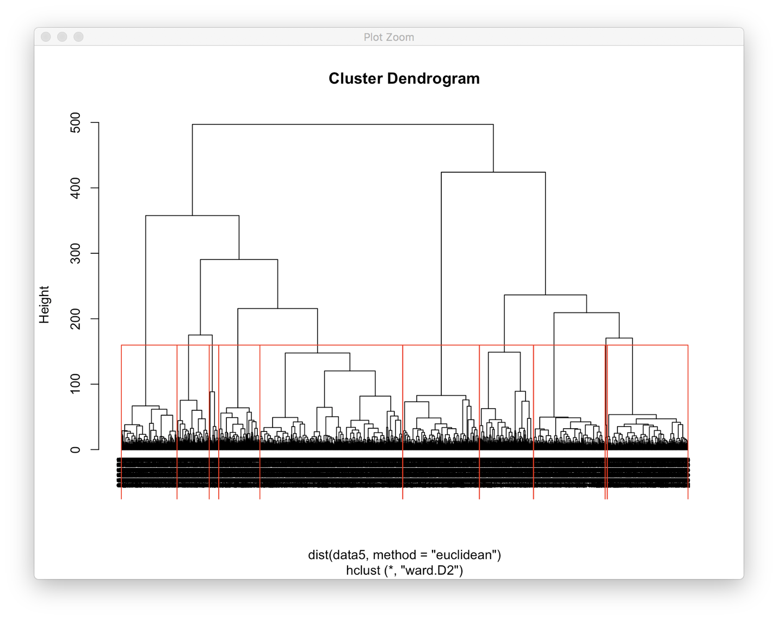
According to GRAPH3, the visualization of the ward hierarchical clustering is quite clear.
2.4 Validate the results.
It is time to measure the accuracy of the clustering. In most cases, we can use
‘intracluster’ or ‘intercluster’ metrics as measurements. The higher the intercluster distance, the
better it is, and the lower the intracluster distance, the better it is. We can use function
‘cluster.stats’ to validate the results. In this validation, the intercluster distance named
‘separation’, and the intracluster distance named ‘Diameter’.
> library(fpc)
>cluster.stats(d, fit$cluster)## validate the k-means clustering.
>cluster.stats(d, fit9)##validate the ward hierarchical clustering
Futhur, I will compare’within.cluster.ss’ and ‘avg.silwidth’, due to the ‘Within.cluster.ss’ shows
a generalization of the within clusters sum of squares, and ‘avg.silwidth’ iss shows how closely
related objects are within the cluster and how clusters are separated from each other.
- Diameter : vector of cluster diameters (maximum within cluster distances).
- Separation: vector of clusterwise minimum distances of a point in the cluster to a point of another cluster.
- Within.cluster.ss shows a generalization of the within clusters sum of squares. It denotes how closely related objects are in clusters; the smaller the value, the more closely related objects are within the cluster. [7]
- ‘avg.silwidth’ is a measurement that considers how closely related objects are within the cluster and how clusters are separated from each other. The range of the silhouette value is usually from 0 to 1; a value closer to 1 suggests the data is better clustered. [7]

TABLE1
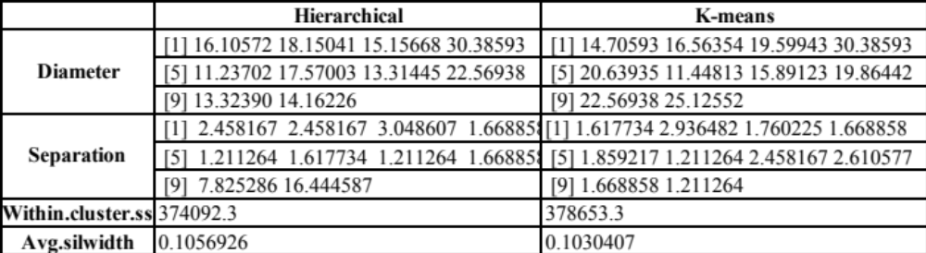
According to TALBE1, the value of diameter, separation, within.cluster.ss and avg.silwidth for
both algorithms are quite similar.
3. Conclusion
From this test, we can see the range of diameters for the two algorithms are both big, and the
range of separation is relatively small. We can make a conclusion that a dataset with high
dimensions has low intra-class similarity and high inter-class similarity. Meanwhile, to
visualize the result for a high dimensional dataset, hierarchical clustering works better than k-
means clustering.
4. Reference
- What is clustering in Data mining.
https://bigdata-madesimple.com/what-is-clustering-in-data-mining/

- K-means
http://stanford.edu/~cpiech/cs221/handouts/kmeans.html

- International Comprehensive Ocean-Atmosphere Data Set
http://icoads.noaa.gov/

- What is R ?
https://www.r-project.org/about.html

- Data Mining Concepts, Models, methods, and Algorithms.
P264. By Mehmed Kantardzic.ISBN :978-0-470-89045-5

- Ward’s Method
https://en.wikipedia.org/wiki/Ward%27s_method

- Exploring Hierarchical clustering in R
https://en.proft.me/2017/01/29/exploring-hierarchical-clustering-r/

